38.77: a) 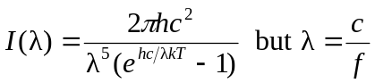
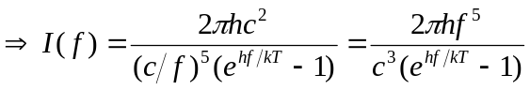
b) 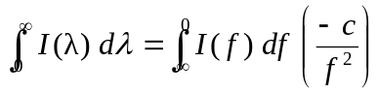
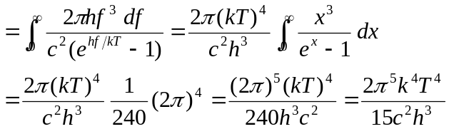
c) The expression 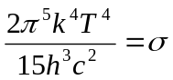 as shown in Eq. (38.36). Plugging in the values for the constants we get 

